PRACTICAL NO 08
Layer 2 VLAN Security
Network Diagram
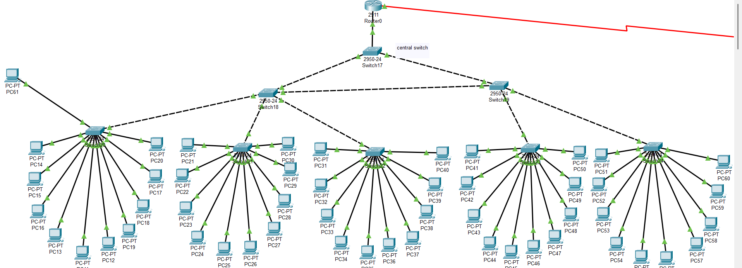
Addresing Table
Device Name | Interface | IP Address | Subnet | Default Gateway
PC 0 | Fa0/2 | 116.0.0.89 | 255.255.255.0 | 116.0.0.169
PC 1 | Fa0/3 | 116.0.0.90 | 255.255.255.0 | 116.0.0.169
PC 2 | Fa0/4 | 116.0.0.91 | 255.255.255.0 | 116.0.0.169
PC 3 | Fa0/5 | 116.0.0.92 | 255.255.255.0 | 116.0.0.169
PC 4 | Fa0/6 | 116.0.0.93 | 255.255.255.0 | 116.0.0.169
PC 5 | Fa0/7 | 116.0.0.94 | 255.255.255.0 | 116.0.0.169
PC 6 | Fa0/8 | 116.0.0.95 | 255.255.255.0 | 116.0.0.169
PC 7 | Fa0/9 | 116.0.0.96 | 255.255.255.0 | 116.0.0.169
PC 8 | Fa0/10 | 116.0.0.97 | 255.255.255.0 | 116.0.0.169
PC 9 | Fa0/11 | 116.0.0.98 | 255.255.255.0 | 116.0.0.169
PC 10 | Fa0/2 | 116.0.0.105 | 255.255.255.0 | 116.0.0.169
PC011 | Fa0/3 | 116.0.0.106 | 255.255.255.0 | 116.0.0.169
PC012 | Fa0/4 | 116.0.0.107 | 255.255.255.0 | 116.0.0.169
PC013 | Fa0/5 | 116.0.0.108 | 255.255.255.0 | 116.0.0.169
PC014 | Fa0/6 | 116.0.0.109 | 255.255.255.0 | 116.0.0.169
PC015 | Fa0/7 | 116.0.0.110 | 255.255.255.0 | 116.0.0.169
PC016 | Fa0/8 | 116.0.0.111 | 255.255.255.0 | 116.0.0.169
PC017 | Fa0/9 | 116.0.0.112 | 255.255.255.0 | 116.0.0.169
PC018 | Fa0/10 | 116.0.0.113 | 255.255.255.0 | 116.0.0.169
PC019 | Fa0/11 | 116.0.0.114 | 255.255.255.0 | 116.0.0.169
PC020 | Fa0/2 | 116.0.0.121 | 255.255.255.0 | 116.0.0.169
PC021 | Fa0/3 | 116.0.0.122 | 255.255.255.0 | 116.0.0.169
PC022 | Fa0/4 | 116.0.0.123 | 255.255.255.0 | 116.0.0.169
PC023 | Fa0/5 | 116.0.0.124 | 255.255.255.0 | 116.0.0.169
PC024 | Fa0/6 | 116.0.0.125 | 255.255.255.0 | 116.0.0.169
PC025 | Fa0/7 | 116.0.0.126 | 255.255.255.0 | 116.0.0.169
PC026 | Fa0/8 | 116.0.0.127 | 255.255.255.0 | 116.0.0.169
PC027 | Fa0/9 | 116.0.0.128 | 255.255.255.0 | 116.0.0.169
PC028 | Fa0/10 | 116.0.0.129 | 255.255.255.0 | 116.0.0.169
PC029 | Fa0/11 | 116.0.0.130 | 255.255.255.0 | 116.0.0.169
PC030 | Fa0/2 | 116.0.0.137 | 255.255.255.0 | 116.0.0.169
PC031 | Fa0/3 | 116.0.0.138 | 255.255.255.0 | 116.0.0.169
PC032 | Fa0/4 | 116.0.0.139 | 255.255.255.0 | 116.0.0.169
PC033 | Fa0/5 | 116.0.0.140 | 255.255.255.0 | 116.0.0.169
PC034 | Fa0/6 | 116.0.0.141 | 255.255.255.0 | 116.0.0.169
PC035 | Fa0/7 | 116.0.0.142 | 255.255.255.0 | 116.0.0.169
PC036 | Fa0/8 | 116.0.0.143 | 255.255.255.0 | 116.0.0.169
PC037 | Fa0/9 | 116.0.0.144 | 255.255.255.0 | 116.0.0.169
PC038 | Fa0/10 | 116.0.0.145 | 255.255.255.0 | 116.0.0.169
PC039 | Fa0/11 | 116.0.0.146 | 255.255.255.0 | 116.0.0.169
PC040 | Fa0/2 | 116.0.0.153 | 255.255.255.0 | 116.0.0.169
PC041 | Fa0/3 | 116.0.0.154 | 255.255.255.0 | 116.0.0.169
PC042 | Fa0/4 | 116.0.0.155 | 255.255.255.0 | 116.0.0.169
PC043 | Fa0/5 | 116.0.0.156 | 255.255.255.0 | 116.0.0.169
PC044 | Fa0/6 | 116.0.0.157 | 255.255.255.0 | 116.0.0.169
PC045 | Fa0/7 | 116.0.0.158 | 255.255.255.0 | 116.0.0.169
PC046 | Fa0/8 | 116.0.0.159 | 255.255.255.0 | 116.0.0.169
PC047 | Fa0/9 | 116.0.0.160 | 255.255.255.0 | 116.0.0.169
PC048 | Fa0/10 | 116.0.0.161 | 255.255.255.0 | 116.0.0.169
PC049 | Fa0/11 | 116.0.0.162 | 255.255.255.0 | 116.0.0.169
Management pc | Fa0/12 | 116.0.0.99 | 255.255.255.0
Switch 1 | Fa0/12 | 116.0.0.85 | 255.255.255.0
Switch 2 | Fa0/12 | 116.0.0.86 | 255.255.255.0
Switch 3 | Fa0/12 | 116.0.0.87 | 255.255.255.0
Switch 4 | Fa0/12 | 116.0.0.88 | 255.255.255.0
Switch 5 | Fa0/12 | 116.0.0.89 | 255.255.255.0
Switch 6 | Fa0/12 | 116.0.0.90 | 255.255.255.0
Switch 7 | Fa0/12 | 116.0.0.92 | 255.255.255.0
Central Switch | Fa0/12 | 116.0.0.91 | 255.255.255.0
Switch 1 VLAN number
Assign and create the vlan:
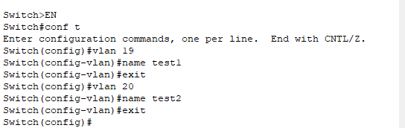
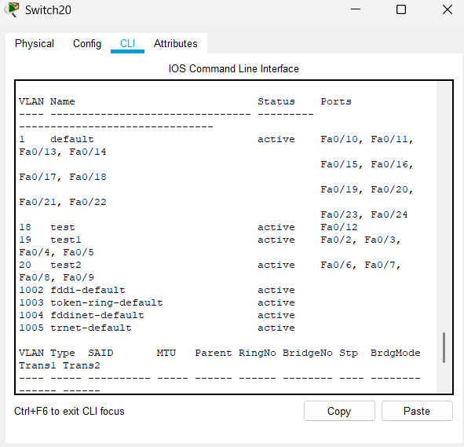

Assign the Access mode on the switch: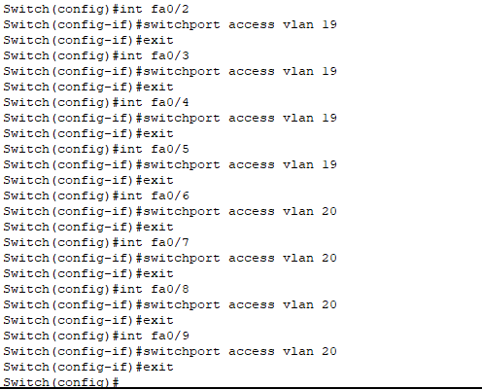
Access the trunk mode on the switches:

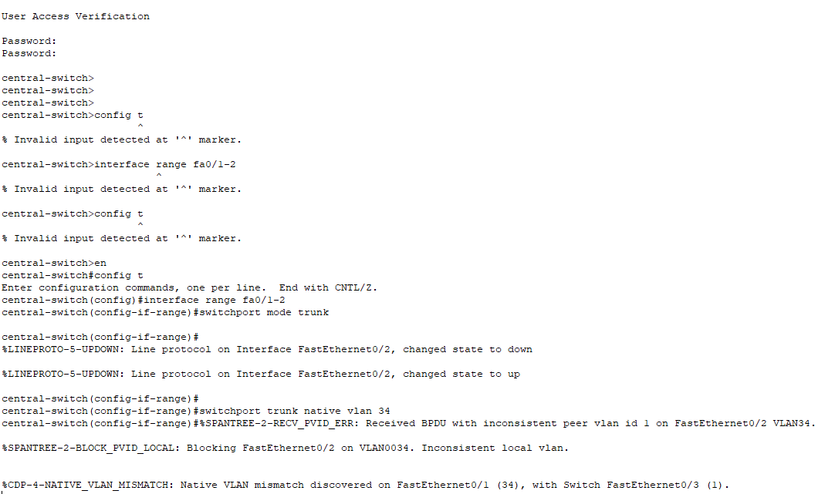

Ping PC 116.0.0.89 to PC 116.0.0.105:

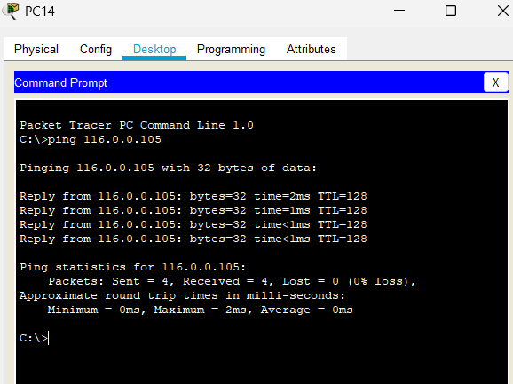

Central switch
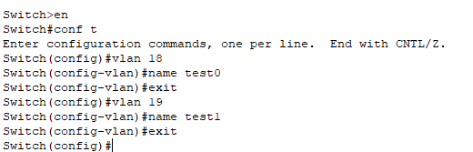

Create the management vlan:
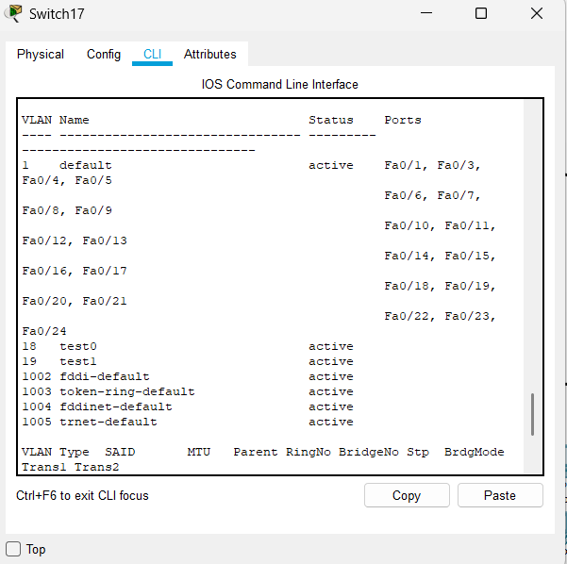
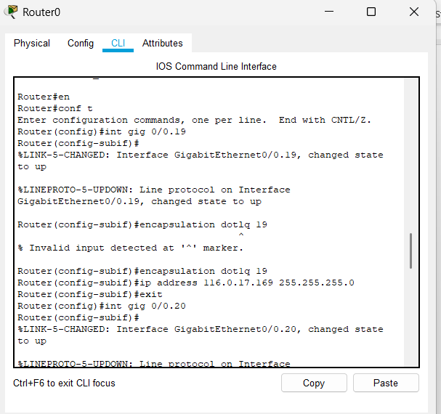

switch1 ip assigning
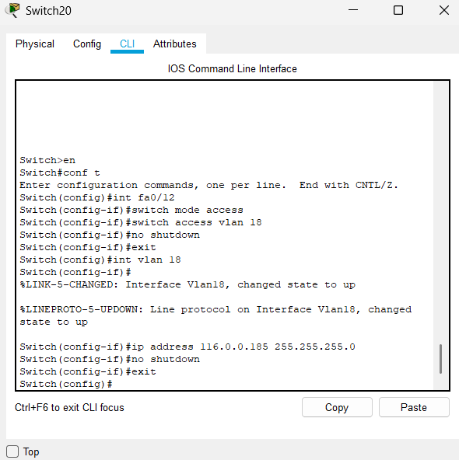
Management pc ping to the Switches:
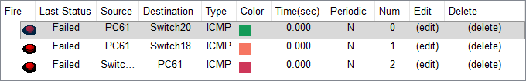
Management pc ping to the Routers:

